EGIA LEAD2022 LIVE VIRTUAL CONFERENCE
BECOMING YOUR BEST GLOBAL LEADERSHIP-Steven R. Shallenberger, Founder
National Best-Selling Author of: Becoming Your Best, The 12 Principles of Highly Successful Leaders
Becomingyourbest.com

NAME: _____________________________

The 5 Most Important Things A Leader Can Do!
- Provide ___________ Leadership.
- Provide ___________ Leadership.
- Provide Leadership on How To ___ ___ ____ ____.
- Provide the Leadership for a _______ & __________ Work Environment.
- Provide for a Culture of ____ ____ ____.

Built on the foundation of Becoming Your Best, the 12 Principles of Highly Successful Leaders.

Your Strategic Plan and Rhythm
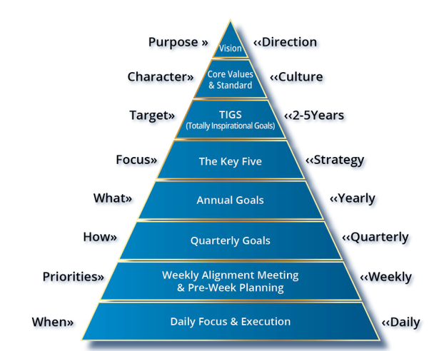

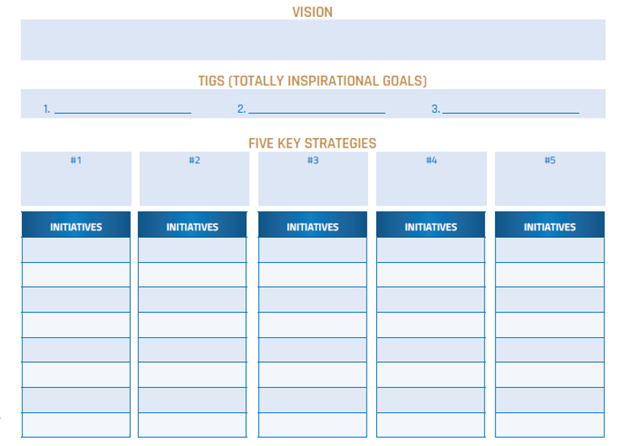
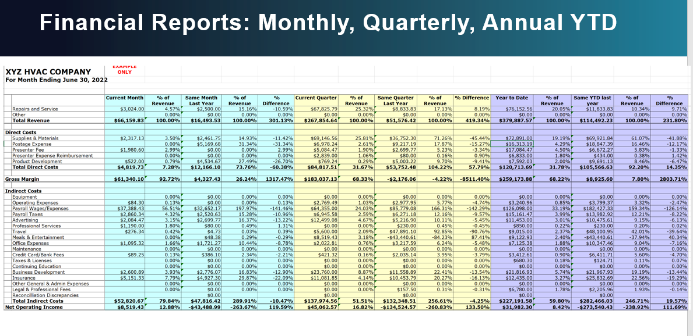
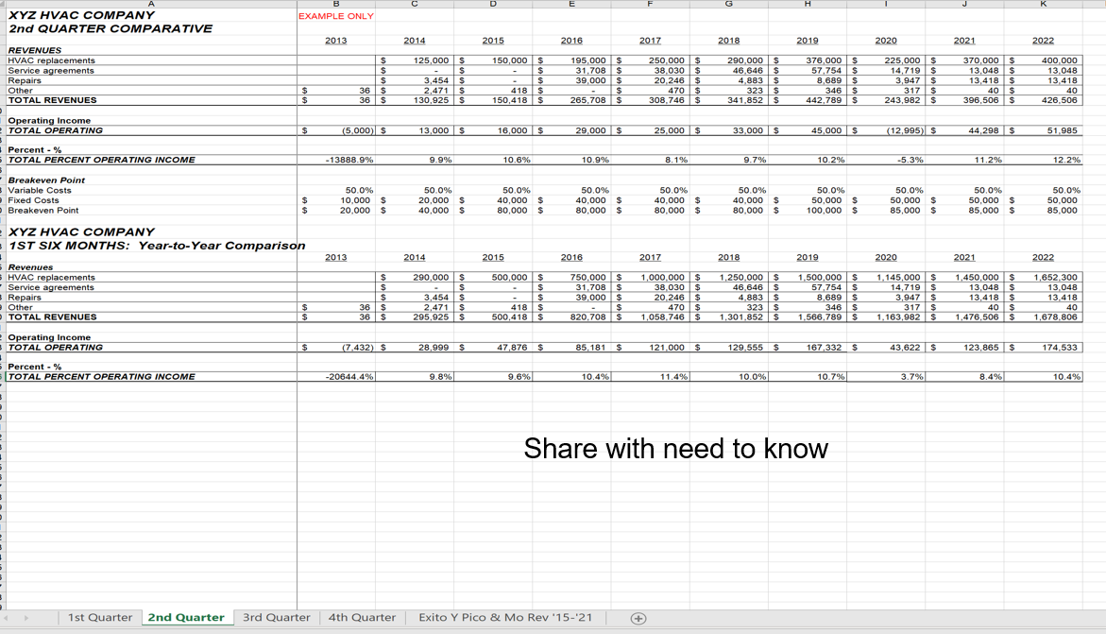
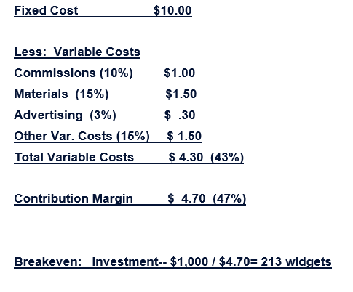
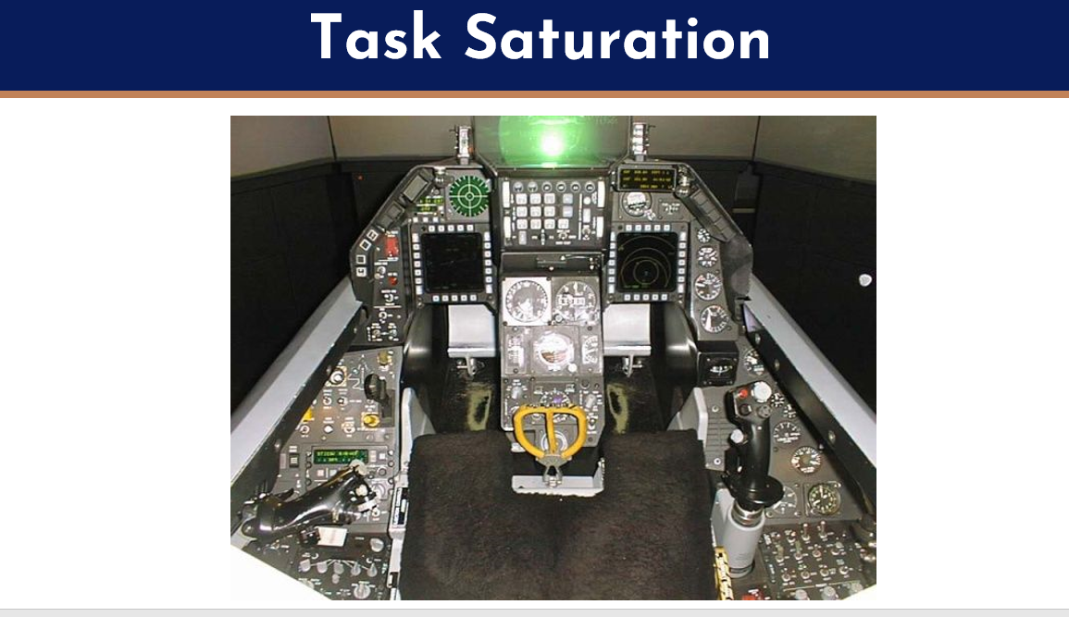
The Big Three High-Performance Habits
Habit #1: Personal Vision (one time).
Habit #2: Roles and Goals® (yearly).
Habit #3: Pre-Week Planning®(weekly).

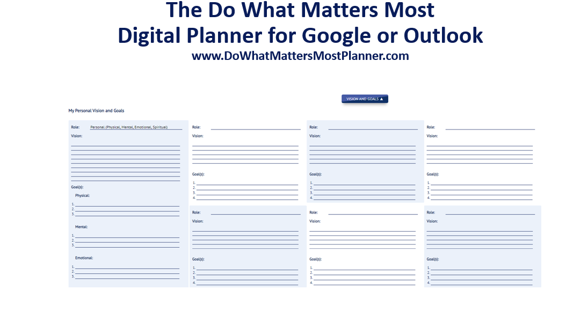
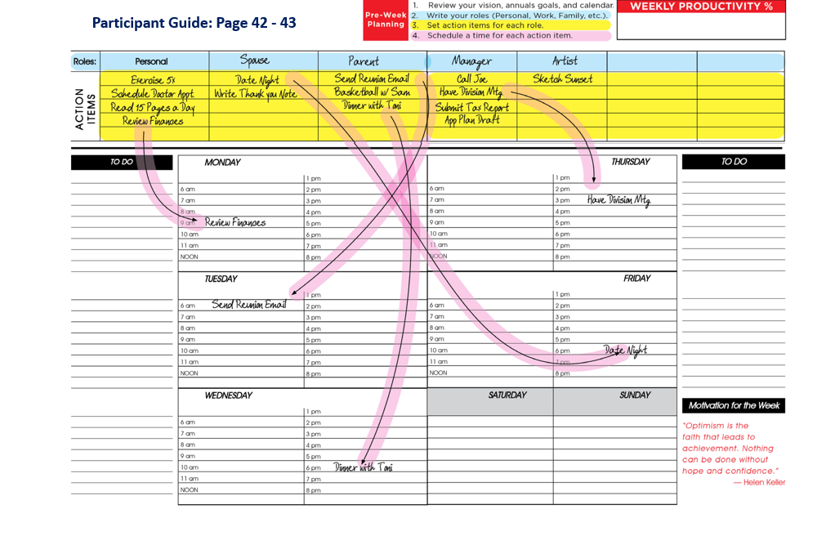
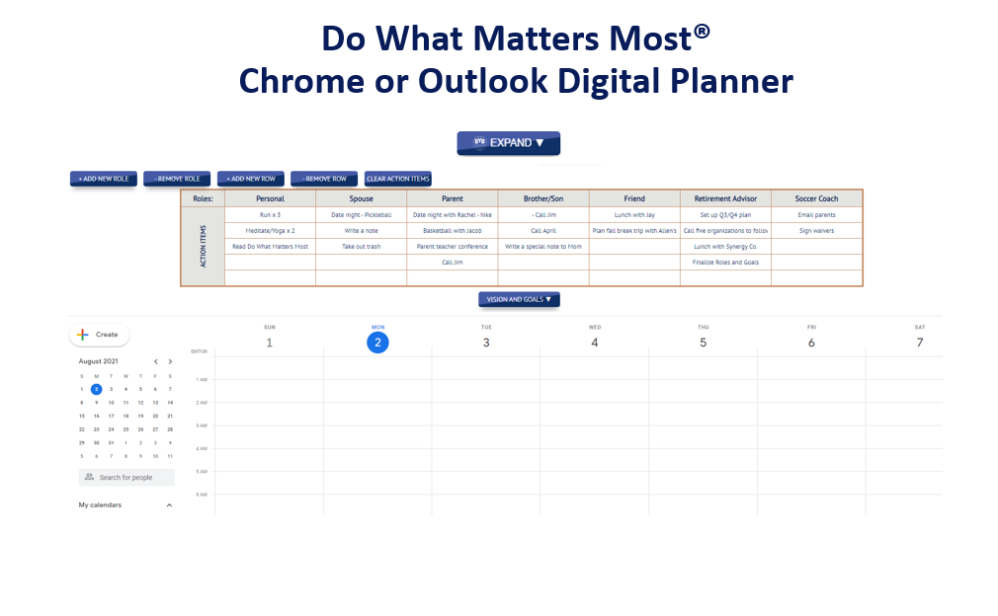

What is your 5,000 shots made goal?
A thing you can do that leads to extraordinary results?

Professional/Work: ____________________________.

Personal: ___________________________________.
Another EGIA Loyalty Rewards Member Benefit
A FREE BYB 2023 Paper-based Planner, along with the Digital Planner for Google or Outlook Calendars, will be provided to EGIA Loyalty Rewards Members in October-November 2022 to help you prepare for a great 2023.

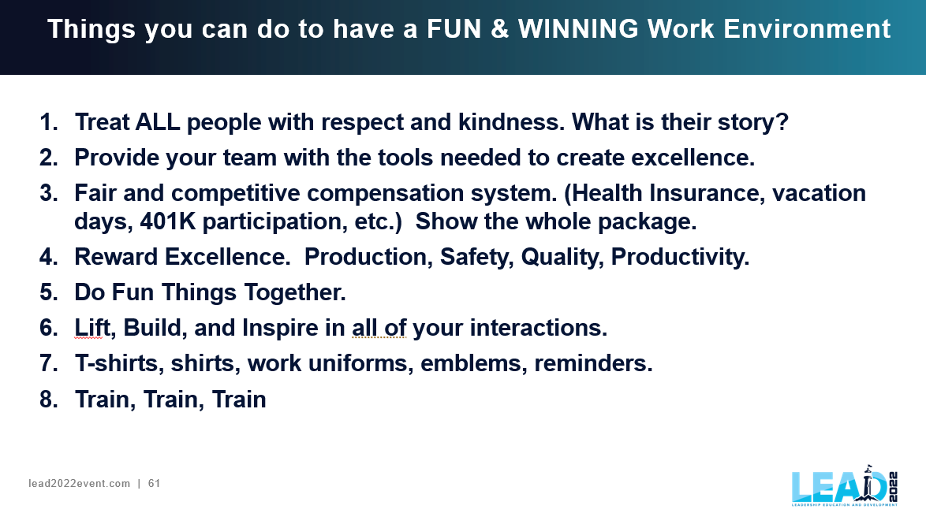
“You will have successes, however, when you have challenges
You will want to fail forward and upward creating
TRIUMPHS (excellence) over and over. “Steve Shallenberger

